**Inertial Measurement Unit (IMU) Using an Accelerometer, Gyro, and Magnetometer**

An IMU is a specific type of sensor that measures angular rate, force and sometimes magnetic field. IMUs are composed of a 3-axis accelerometer and a 3-axis gyroscope, which would be considered a 6-axis IMU. They can also include an additional 3-axis magnetometer, which would be considered a 9-axis IMU. Technically, the term “IMU” refers to just the sensor, but IMUs are often paired with sensor fusion software which combines data from multiple sensors to provide measures of orientation and heading. In common usage, the term “IMU” may be used to refer to the combination of the sensor and sensor fusion software

An IMU provides 2 to 6 DOF (Degrees of Freedom), which refers to the number of different ways that an object is able to move throughout 3D space. The maximum possible is 6 DOF, which would include 3 degrees of translation (flat) movement across a straight plane/along each axis (front/back, right/left, up/down) and 3 degrees of rotational movement across the x, y and z axes/about each axis.

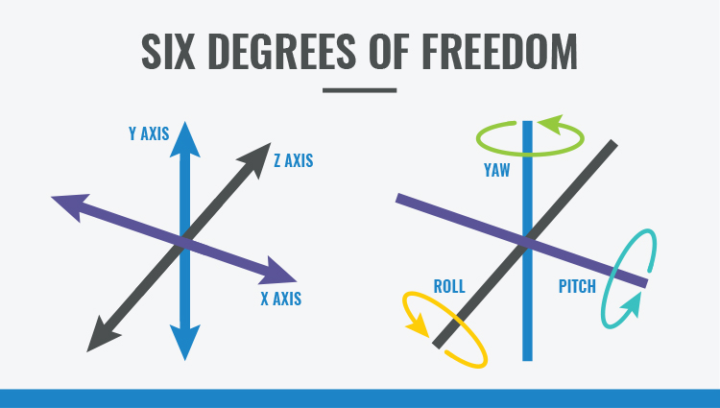

The raw data collected from an IMU gives some idea of the world around it, but that information can also be processed for additional insight. Sensor fusion is the (mathematical) art of combining the data from each sensor in an IMU to create a more complete picture of the device’s orientation and heading. For instance, while looking at gyroscope information for rotational motion, you can incorporate an accelerometers sense of gravity to create a reference frame. You can additionally add information about the Earth’s magnetic field to align the whole sensor to the Earth’s frame.

An inertial measurement unit works by detecting linear acceleration using one or more [accelerometers](https://en.wikipedia.org/wiki/Accelerometer) and rotational rate using one or more [gyroscopes](https://en.wikipedia.org/wiki/Gyroscope).[[6]](https://en.wikipedia.org/wiki/Inertial_measurement_unit#cite_note-IosaPicerno2016-6) Some also include a [magnetometer](https://en.wikipedia.org/wiki/Magnetometer) which is commonly used as a heading reference.

# Useful links

# To buy imu : <https://www.sparkfun.com/categories/160>

# Another resource : <https://www.eecs.umich.edu/courses/eecs373/Lec/StudentF18/373%20IMU%20Presentation.pdf>